MS.NET
Mini Project
Hotel Bookings Management System
(HBMS)

Document Revision History

Date | Revision No. | Author | Summary of Changes
28th Sept. 2015 | 1 | Nachiket Inamdar | Initial Draft
13th July 2016 | 1 | Vijay Vishwakarma | Incorporating changes as per new curriculum

Table of Contents
1 Introduction 4
1.1 Setup Checklist for Mini Project 4
1.2 Instructions 4
2 Problem Statement 5
2.1 Objective 5
2.2 Abstract of the project 5
2.3 Functional components of the project 5
2.4 Technology used: 6
3 Implementation 7
3.1 Summary of the functionality to be built: 7
3.2 Guidelines on the functionality to be built: 8
3.3 Evaluation and assessment parameters: 12

Introduction

This document outlines a mini project for the .NET LOT. The project is to develop an online Hotel Bookings Management System (HBMS) for a website “CheapStays.com”. This document contains the work flow of the system and gives guidelines on how to build the functionality gradually in each of the course modules of the .NET LOT.

Setup Checklist
Minimum System Requirements
- Intel Pentium 4 and above Windows XP, 2000 and 2003
- Memory 1 GB
- Internet Explorer 6.0 or higher
- SQL Server 2012 client and access to SQL Server 2012 server
- Visual Studio 2013

Instructions
- The code modules in the mini project should follow all the coding standards.
- Create a directory by your name in drive <drive>. In this directory, create a subdirectory MiniProject. Store your Project here.
- You can refer to your course material.
- You may also look up the help provided in the MSDN
- Since this project work will span over couple of months, you will need to take care of maintaining the code

Problem Statement

Objective
Development of an online Hotel Bookings Management System (HBMS)

Abstract of the project
This project is aimed at developing an online Hotel Bookings Management System (HBMS). This is a web based application that can be accessed over the web. This system can be used to search for Hotel rooms and reserve them.

There are three categories of people who would access the system viz. customer, hotel-employee & Admin. Each one of them would have some exclusive privileges (for e.g. customer and hotel-employee can just search for hotel rooms and reserve them, but only the admin has the right to add new and modify hotels.)

- Customer and Hotel-Employee should be able to
  - Register into the system.
  - Login to the system using his/her credentials.
  - Search for hotel rooms.
  - Book hotel rooms.
  - View Booking Status

- The Admin should be able to
  - Login to the system using his/her credentials
  - Perform Hotel Management (add/delete/modify Hotel info like description, any special offers etc)
  - Perform Room Management (add/delete/modify Rooms, modify room tariff)
  - Generate various reports like:
    - List of Hotels
    - Bookings of specific hotel
    - Guest list of specific hotel
    - Bookings for specified date
Note: Other that First Time registration, the other operations are allowed only for registered customers.

The Payment mode will be Cash.

Develop the Application for the above requirement using MS.NET Technology.

Functional components of the project
Application Architecture:
Distributed web applications traditionally to be designed and built across three logical tiers:
- Database Access Layer (DAL)
- Business Logic Layer (BLL)
- Presentation Layer

The DAL refers to the database itself, the stored procedures, and the component that provides an interface to the database. The BLL refers to the component that encapsulates all the business logic of the application. And, the Presentation layer refers to the web application pages.

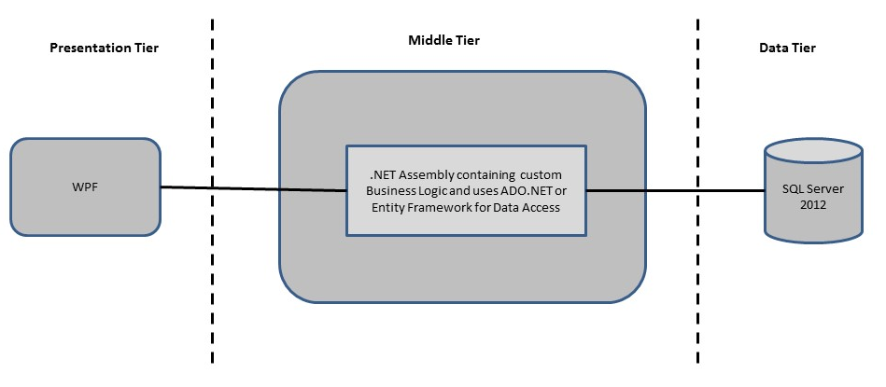

- Design guidelines
- All the exceptions/errors to be captured and user friendly message to be displayed on the Common Error page (to be done during PLP).
- Presentation layer comprises of Winforms and WPF
- Data access layer Use ADO.NET. Make use of stored procedures. All the database interaction would be performed using Data Access Component. Most common methods in Data Access Component would be –
- Create Connection to the Database
- Create Command Object
- Set Command Type to Stored Procedure
- Create and Populate Parameters
- Execute the Command
- Close the Connection

Technology used:
    - Presentation Layer
        - WPF 4.5

    - Business Layer
      - Business Logic Components and Services :-
        - C# 5.0

    - Database Layer
      - Databases:-
        - SQL Server 2012

Note: Saturday half day will be devoted for mini project

Implementation

Summary of the functionality to be built:
The participants need to develop the online Hotel Bookings Management System (HBMS)
by building the functionality incrementally in each of the course modules of .NET LOT.

Sr. No | Course | Duration | Functionality to be built
Sr. No | Course | (in PDs) | Functionality to be built
1 | MS SQL Server 2012 | 4 | Creating relevant database tables and stored procedures
2 | NET Framework 4.5 + C# 5.0 | 7.5 | Developing Business components (C# classes)
3 | ADO.NET 4.5 | 3 | Integrating the DAL and BLL And PL
4 | LINQ and Entity Framework | 2 | Creating data model and data context and using LINQ to Entities
5s | WPF 4.5 | 2 | Incorporating advanced UI functionality with WPF 4.5
6 | Mini Project Presentation | 1 | The Mini Project Presentation day

Guidelines on the functionality to be built:

The functionality and components to be built in each of the course modules of .NET LOT is as follows:
- Course: SQL Server 2012
This section describes some of the basic steps involved in designing and creation of the database for the application.

Create Data Model - identify the different tables and fields that we will need, which would later be used for building the rest of the application.

Database Schema - Create the following database tables:
i) Users: This contains the list of valid users with details
ii) Hotel: This will contain the list of hotels.
iii) RoomDetails: This will contain the details of all the rooms available in all the hotels.
iv) BookingDetails: This will contain the list of booked rooms and their details.

The structure of the above listed tables is as follows:

i) Users: user_id varchar(4), password varchar(7), role varchar(10), user_name varchar (20), mobile_no varchar(10), phone varchar(10), address varchar(25), email varchar(15)

ii) Hotel: hotel_id varchar(4), city varchar(10), hotel_name varchar(20), address varchar(25), description varchar(50), avg_rate_per-night int, phone_no1 varchar(10), phone_no2 varchar(10), rating varchar(4), email varchar(15), fax varchar(15)

Note : Description here could be a brief teaser about the hotel like – “Centrally located in the main city centre at Shivajinagar Railway Station, this budget accommodation is designed with spacious rooms…”. It could also give some special offers etc.

iii) RoomDetails: hotel_id varchar(4), room_id varchar(4), room_no varchar(3), room_type varchar(20), per_night_rate int, availability bit, photo image

Note : Room_type could be Standard non A/C room, Standard A/C room, Executive A/C room, Deluxe A/C room etc.

iv) BookingDetails: booking_id varchar(4), room_id varchar(4), user_id varchar(4), booked_from date, booked_to date, no_of_adults, no_of_children, amount int

Note : You may add/normalize/denormalize the tables if your application so demands it.

- Course: sWPF 4.5
  - Develop the prototypes for following functionalities:
    - Login / Sign In: Login screen would display asking user to enter ‘User Id’ & ‘Password’. If the supplied user credentials are valid the HomePage would be displayed, else appropriate Login error message would be displayed
    - First time users Register: First time new users would use this screen to create their profile (userId and password). On click of ‘Submit’ button new user entry (user id & password) would be saved into database table for further user authentication purpose
    - Home Page: On successful user authentication (validation of userid/password provided by the user in login screen) the homepage would be displayed. The Homepage would contain below sections/contents:

Header section: The header section would be common across all the pages and would mainly have –

Sign Out Link – On click it would take to Login page

Main content section: It would display generic Welcome message giving overview of the site. Also it would display following links/images:

    - View Hotel screen: For all the users, this screen shows a list of hotels and rooms.
    - Book Rooms: For the customers and the hotel-employees, this screen will allow booking of available hotel rooms.
    - Add Hotels: This screen allows the admin to add new hotels or rooms.
    - Update Hotels: This screen allows the admin to update existing hotels or rooms.
    - Delete Hotels: This screen allows the admin to delete existing hotels or rooms.
    - View Reports: This screen offers administrator to view various reports by clicking on an appropriate link.

  - In this course you need to develop the user interface using Winforms and WPF. The screens should include the fields as per the functionality mentioned above. Include Validations where ever required.

- Course: C# 5.0 and ADO.NET 4.5
  - Develop business components (C# classes) for the following functionality:
    - Users Class: The Customers class contains the methods that pertain to the user. The process begins with the User Authentication. If the User does not exists in the database, then the class allows to Add a new user in the Users table.

    - Hotel Class: This class will handle access to the Hotel and RoomDetails table in the database. This class will provide the functionality
a) To retrieve the data from Hotel Table. The Hotel table maps to the RoomDetails table, which contains all of the available rooms which the user can book.
b) To return the set of rooms that corresponds to the selected category.
c) To add a new hotel

    - RoomDetails Class: This class is the most important class in the project. Keeping track of what kind of room user wants to book is very important. This class is used to maintain the information about the rooms. This class will provide the functionality to book the room.

    - BookingDetails Class: This class will provide list of booked rooms along with the booking details.

You need to create Layered Architecture which comprises of PresentationLayer (winforms,WPF),Business Logic Layer (C# Classes) and DAL Layer(Using ADO.Net 4.5 or Linq and Entity Framework)

DAL Layer of ADO.NET 4.5 will include all the required code snippets for CRUD Operations.

All the CRUD operations should use SQL Server Stored Procedures(For Insert,Update,Delete & Search).

The connectionString should be stored in the configuration file only.
OR

- Course: LINQ and EF
  - Use database first approach and create a entity data model based on the existing database which will consist of the following entities
    - User Class :- This class will store user related information
    - Hotel Class :- This class will store the information about the hotel
    - RoomDetails Class :- This class will store the information about the rooms based on hotel
    - BookingDetails Class :- This class will store the booking information of the users with respect to hotel and rooms.
  - Use DataContext to perform CRUD operations and LINQ to implement the required logic(like retrieving data, sorting data ,searching data etc).

- Course: ADO.NET 4.5 and WPF 4.5
  - Integrate all screens (WPF ) with business components (C# classes) to complete the entire functionality.

Project Evaluation Guidelines

The project it is to be evaluated based on the following five parameters:

- Proper Database Structure and UI designing as per the specifications –(15 Marks)
  - Proper Database Design and Stored Procedure
  - Visual look and feel of the UI
- Project Completion – (20 Marks)
  - Timely Completion of the project
  - Integration of all component of the system
- Defect free execution – (30 Marks)
  - Error free execution of individual modules and the whole system
  - Validation
  - Functionality as per the specified requirements
- Compliance of standard and guidelines – (15 Marks)
  - Appropriate comments entries
  - Adherence to naming conventions for classes, functions, variables and files
  - Simplicity of user interface and screen layouts
  - Maintainability of codes (for example, no one function should be more than 100 lines)
- Group Presentation and Query handling – (20 Marks)
  - Participants (Group of 3 to 4) to present the project with UML Diagrams(use case diagram and one of the sequence or activity diagram) and PPT

